**Info**

Your Name: Russell Reiter

**App Summary**

**Github (Capstone Repo):**

[**https://github.com/alagrad94/BackEndCapstone**](https://github.com/alagrad94/BackEndCapstone)

**Name of Project:**

MoneyTree

**Overview of app:**

My father, two of my nephews and I build furniture and other woodworking projects in my father’s wood shop and sell them. However, we have a very difficult time tracking the costs that we have in each project because we have no system of recording them as we go. Some of the projects take months to complete, which makes this task even more difficult. This app will allow us to create a new project, associate at a customer with the project when it’s for an order, and add project costs by category (labor, materials, supplies) on a daily basis. When the project is complete, we can enter the price we charged for the item, or if it wasn’t for an order, the amount we sold it for and use that number to calculate the profit/loss on each item. As we accumulate historical data, this will allow us to more accurately price our items.

**MVP Definition:**

1. User registration/login
2. Create/edit/delete cost items
3. Create/edit/delete cost per unit records
4. Create/edit/delete cost categories
5. Create/edit/delete customers
6. Create/edit/delete a project
7. Create/edit/delete cost items associated with a project and total all costs on a project
8. Display project details to include calculating Profit/Loss based on invoice amount and total of cost items

**Are you using MVC with entity, MVC with ADO .NET, or react with c# API?:**

Uncertain. It will be either MVC with entity or React with C# API. I’m still discussing this with the family, several of them want to be able to access the application via a mobile app, so I’m considering a React Native front end.

### **Planning Links**

**Link to Repo Issues:**

[**https://github.com/alagrad94/BackEndCapstone/issues**](https://github.com/alagrad94/BackEndCapstone/issues)

**Moq-up/Wireframes(picture or link):**

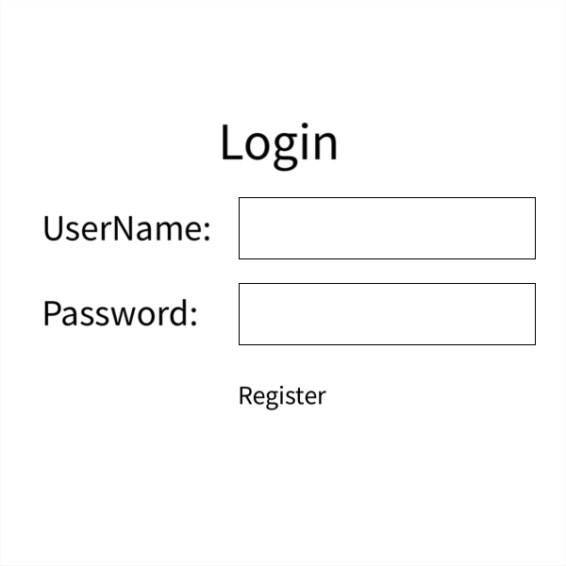

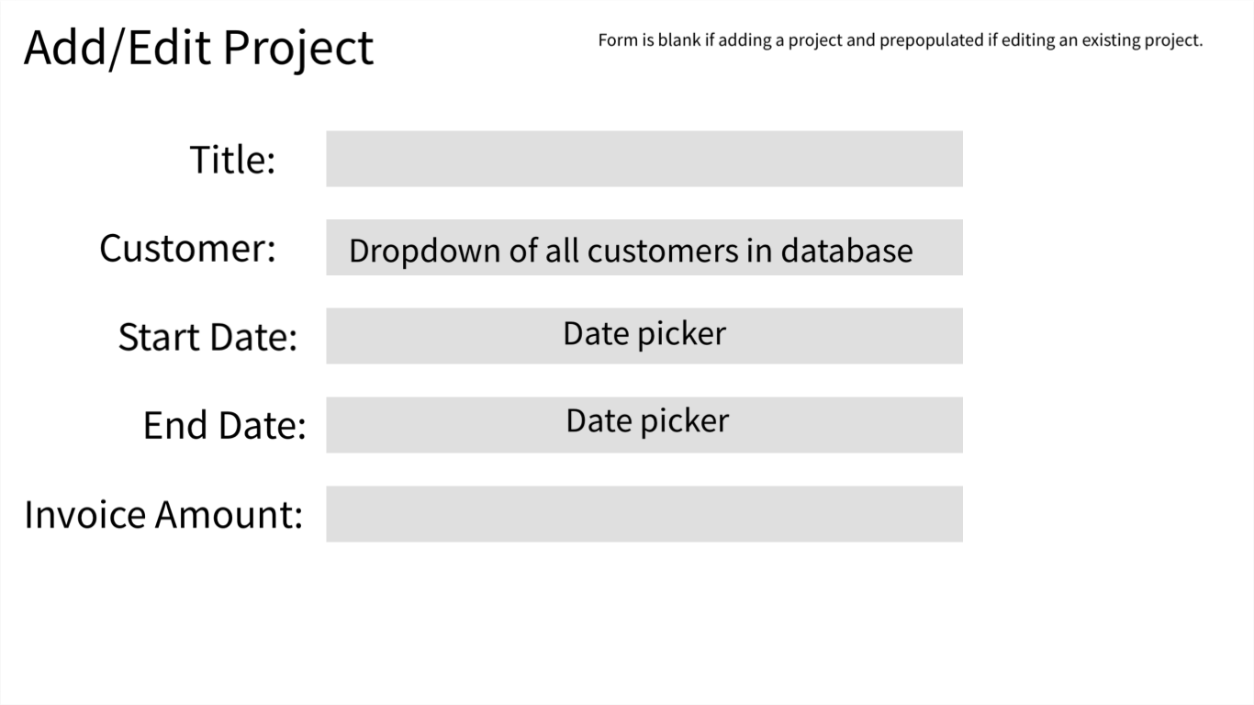

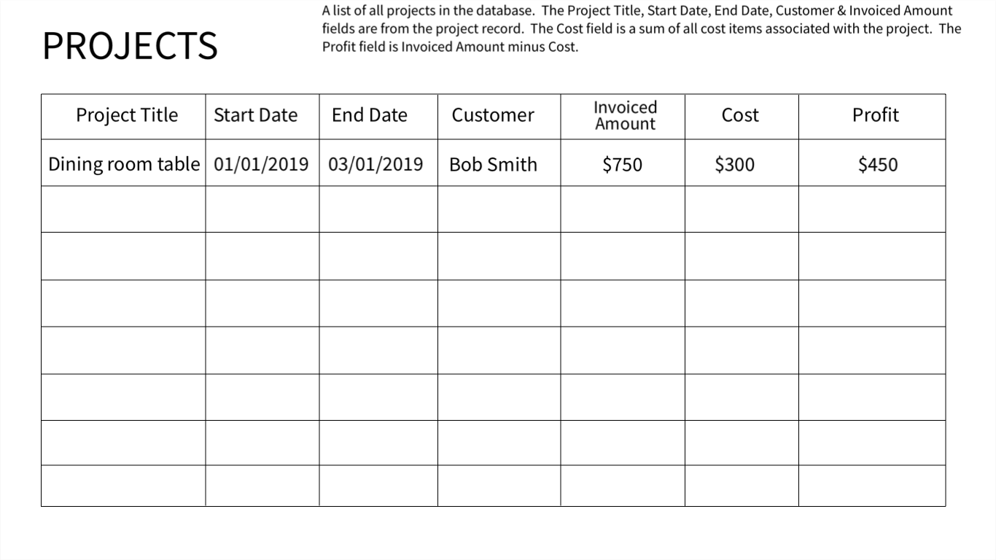

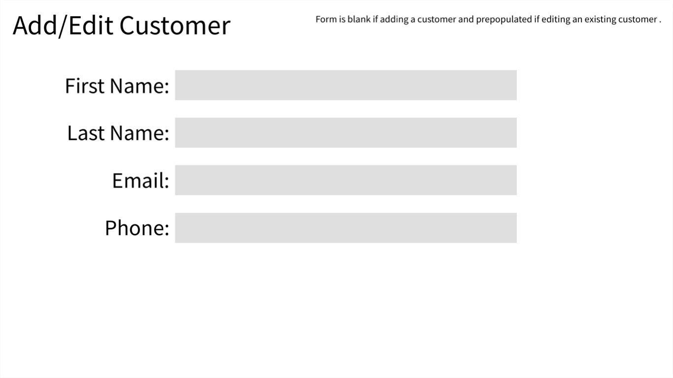

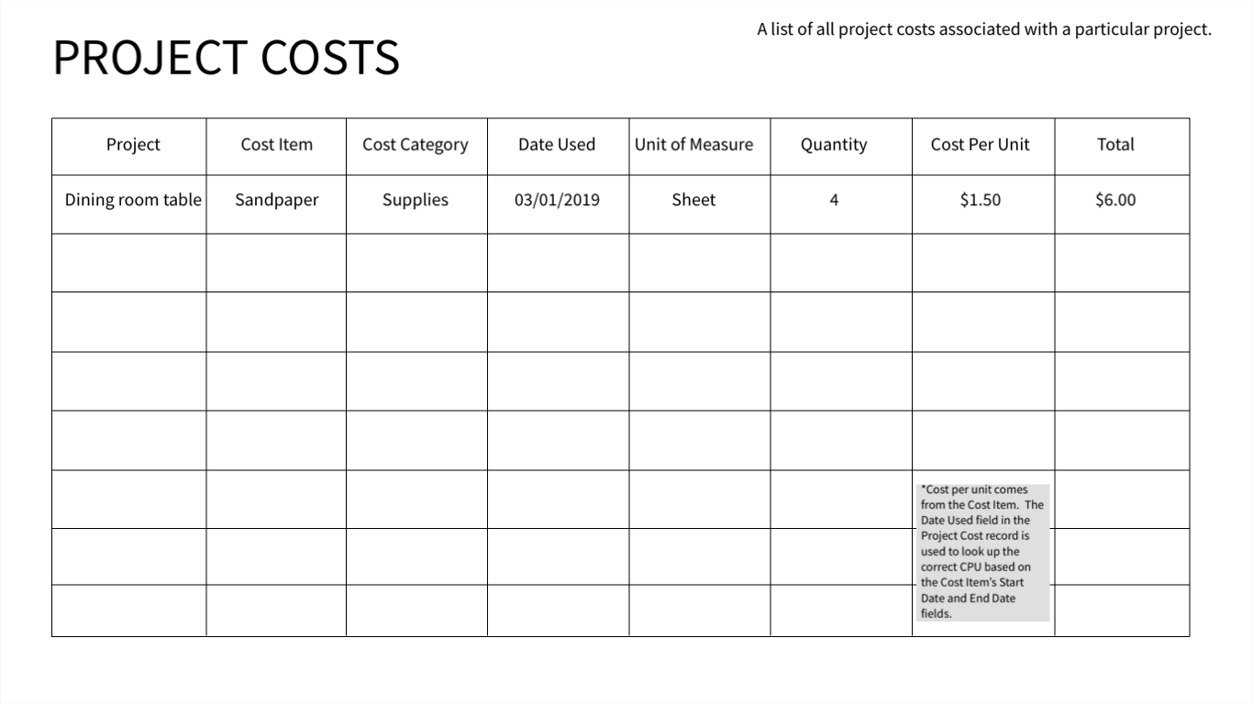

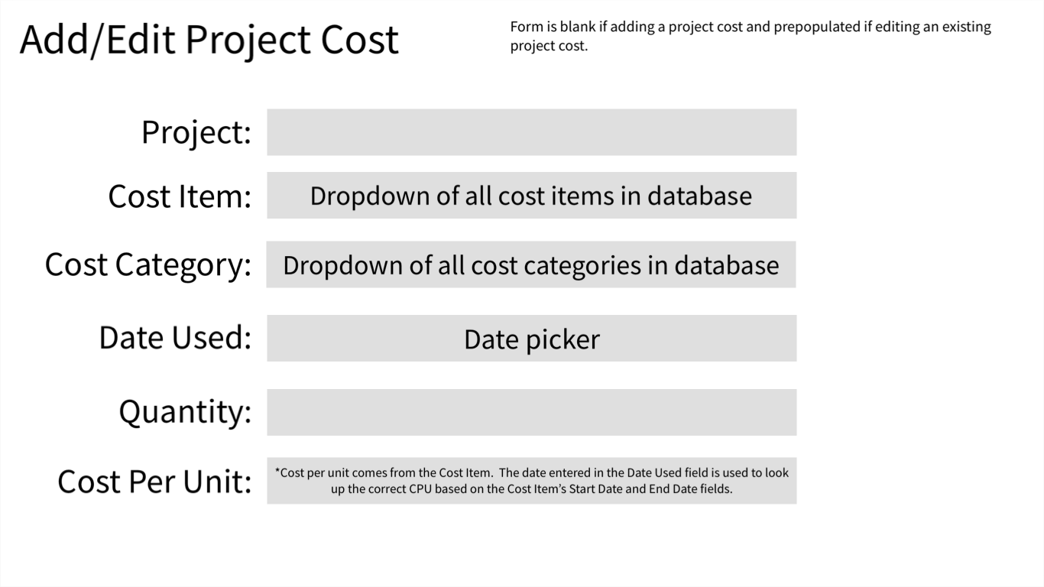

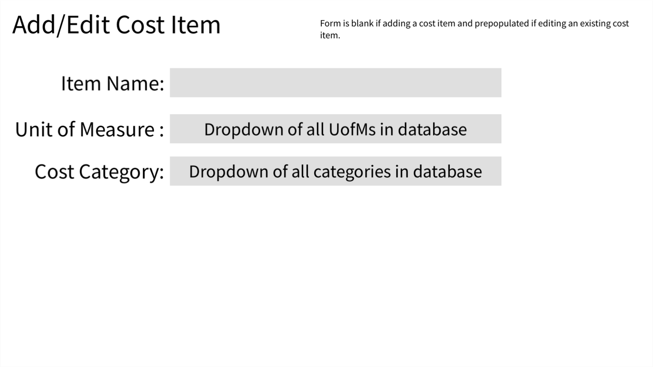

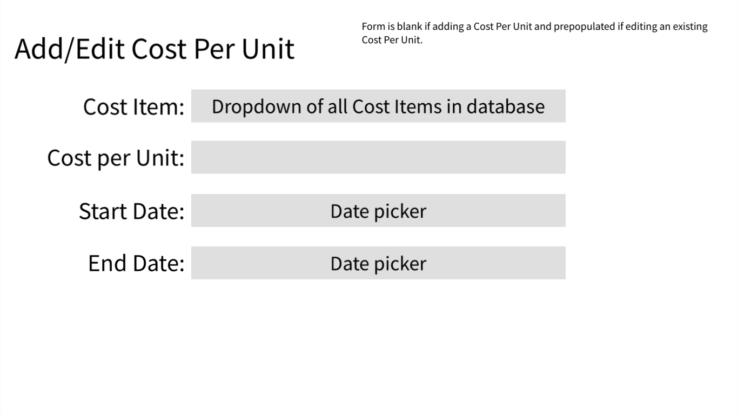

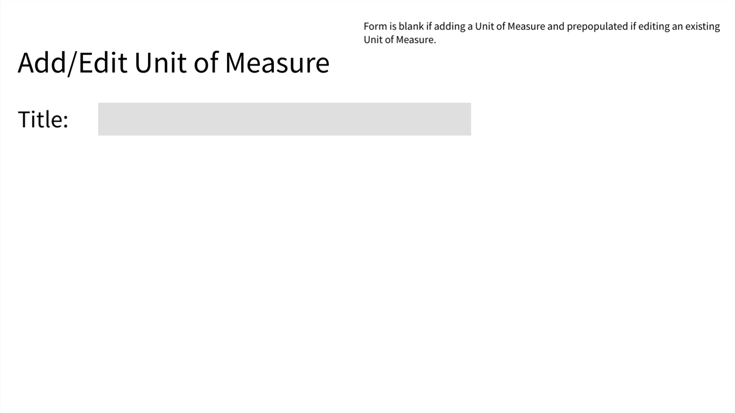

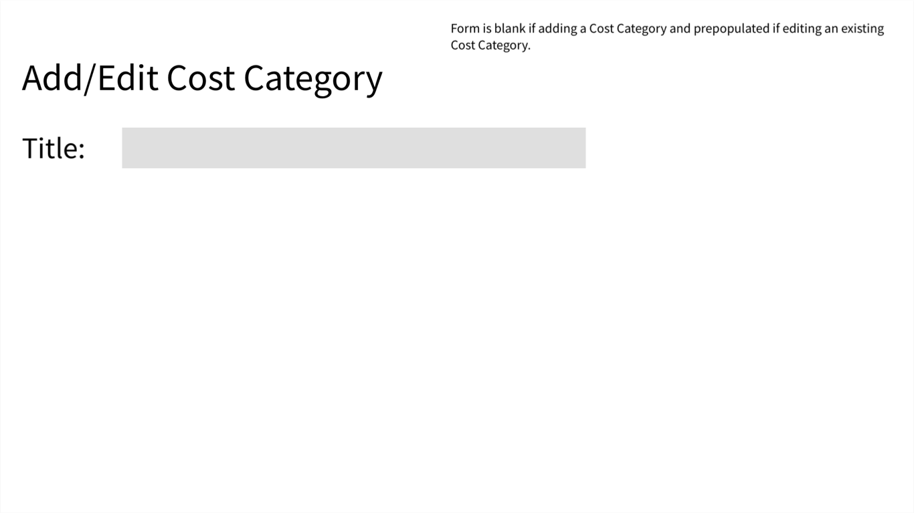

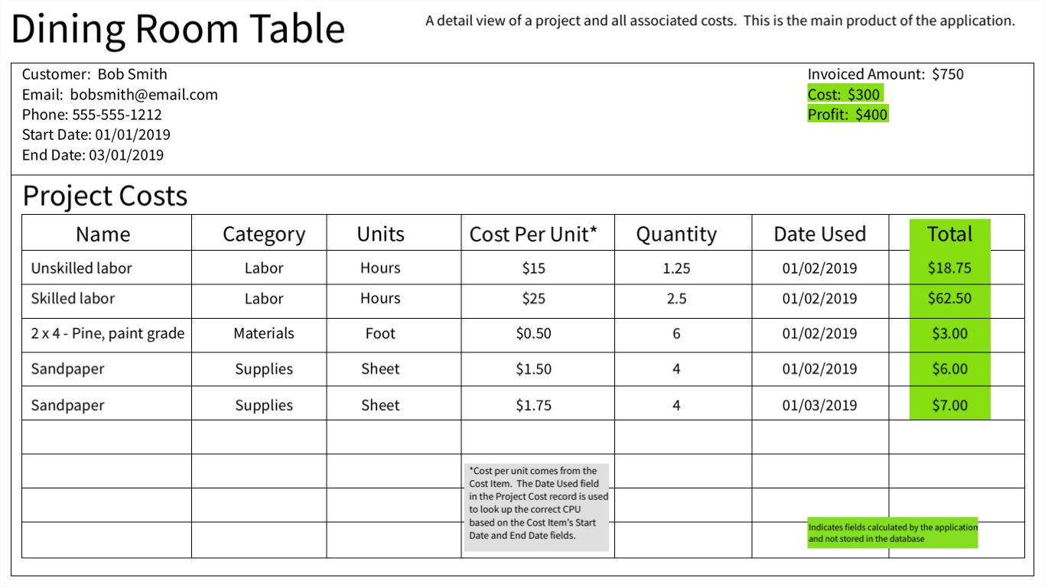

**ERD (picture or link):**

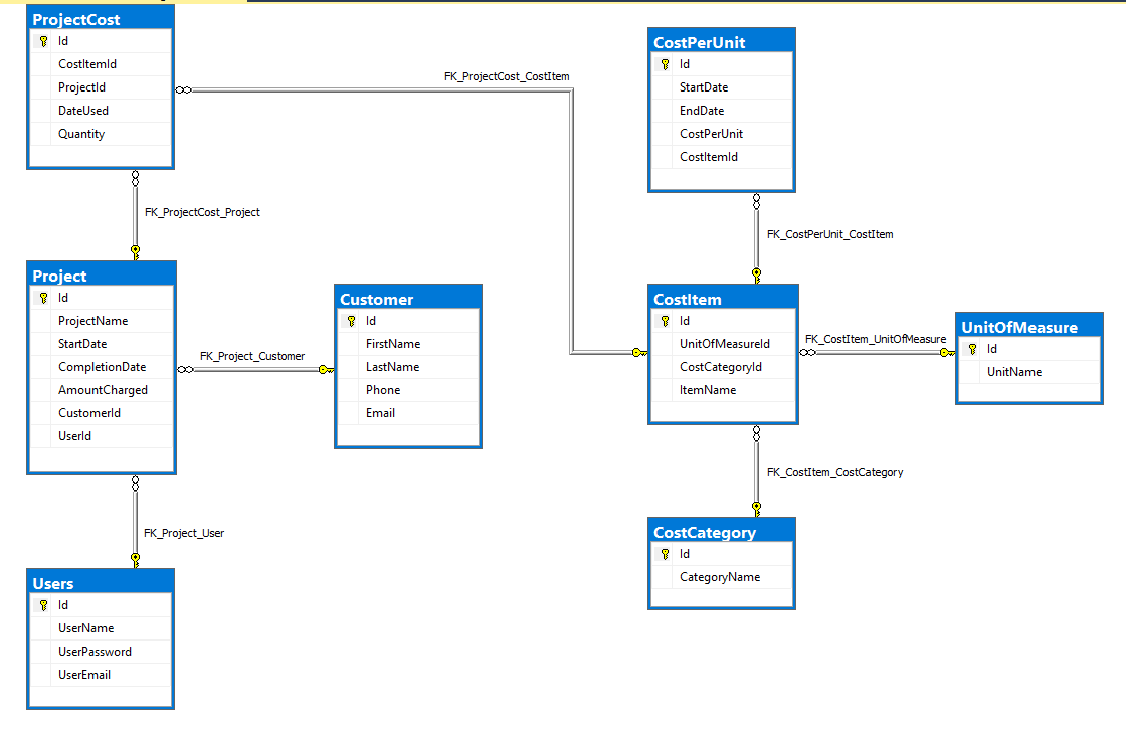

**Capstone Issue Tickets:**

1. User login

**Story:** As a user, I should be able to fill out a form with my name, phone number, email address, and the username/password of my choice to register myself in the application

**Acceptance Criteria:**

**Given:** a user wants to use MoneyTree

**When:** the user first accesses the application

**Then:** the user should see a welcome message

**And:** a hyperlink to the registration form

**Given:** a user wants to register an account with MoneyTree

**When:** the user clicks the Register a new account hyperlink

**Then:** a registration form should be displayed where the user can enter required personal information

**Given:** a user has filled out fields of the registration form

**When:** the user clicks the Register button

**Then:** the system should check if the username and email are unique

**And:** if both are unique, a new account should be created

**And:** the user should be taken to the main view of MONEYTREE

2. Create/edit/delete cost categories

**Story:** As a user, I should be able to create a new cost category, edit existing categories and delete existing categories.

**Acceptance Criteria:**

**Given:** a user wants to create a new cost category

**When:** the user navigates to the Cost Categories page

**Then:** the user clicks the "Create New" link

**Then:** the "Create Cost Category" form is displayed where the user can enter the new Category Name

**When:** the user clicks the Submit button, a new record is created in the database

**Given:** a user wants to edit an existing cost category

**When:** the user navigates to the Cost Categories page

**Then:** the user clicks the "Edit" link of an existing category

**Then:** the "Edit Cost Category" form is displayed where the user can edit the Category Name

**When:** the user clicks the Submit button, the category record is updated in the database

**Given:** a user wants to delete an existing cost category

**When:** the user navigates to the Cost Categories page

**Then:** the user clicks the "Delete" link of an existing category

**Then:** the "Delete Cost Category" form is displayed where the user must choose a new category to which all cost items currently in the category being deleted will be reassigned

**When:** the user clicks the Submit button, the category record is deleted from the database and the CostItemId is updated in all associated cost item records to reflect their new category

3. Create/edit cost item records

**Story:** As a user, I should be able to create new record that establishes a cost items and places it in a cost category, and edit existing cost item records.

**Acceptance Criteria:**

**Given:** a user wants to create a new cost item

**When:** the user navigates to the Cost Items page

**Then:** the user clicks the "Create New" link

**Then:** the "Create Cost Item" form is displayed where the user can enter the new Item Name, choose a Unit of Measure and select a Cost Category

**When:** the user clicks the Submit button, a new record is created in the database

**Given:** a user wants to edit an existing cost item

**When:** the user navigates to the Cost Items page

**Then:** the user clicks the "Edit" link of an existing item

**Then:** the "Edit Cost Item" form is displayed where the user can edit the Item Name, choose a new Unit of Measure and select new a Cost Category

**When:** the user clicks the Submit button, the cost item record is updated in the database

4. Create/edit cost per unit records

**Story:** As a user, I should be able to create new cost per unit records that record the cost of items in a date range and edit existing cost per unit records. A CPU record should be considered "Open" if it has a valid "Start Date" and the "End Date" is NULL. The system should allow only one CPU record to be "Open" at any given time for each Cost Item and no two CPU records for a Cost Item will have overlapping date ranges.

**Acceptance Criteria:**

**Given:** a user wants to create a new Cost Per Unit record

**When:** the user navigates to the Cost Per Unit page

**Then:** the user clicks the "Create New" link

**Then:** the "Create Cost Per Unit" form is displayed where the user can select the Cost Item, enter the start date of the date range and the cost per unit

**When:** the user clicks the Submit button, a new record is created in the database and if the associated Cost Item has an Open CPU record, that record should be closed with an End Date which is 1 day before the Start Date entered in the new record

**Given:** a user wants to edit an existing cost per unit

**When:** the user navigates to the Cost Per Unit page

**Then:** the user clicks the "Edit" link of an existing Cost Per Unit

**Then:** the "Edit Cost Per Unit" form is displayed where the user can edit the Start Date, End Date and Cost Per Unit

**When:** the user clicks the Submit button, the system should verify 1) the edited record doesn't create an overlap of CPU records associated with the Cost Item 2) the edited record doesn't create a date gap where no CPU information is available if the associated Cost Item is assigned to a project with a "Date Used" value in the gap that would be created

5. Create/edit/delete customers

**Story:** As a user, I should be able to add, edit and remove customer records from the database.

**Acceptance Criteria:**

**Given:** a user wants to create a new customer

**When:** the user navigates to the Customers page

**Then:** the user clicks the "Create New" link

**Then:** the "Create Customer" form is displayed where the user can enter the new customer's first name, last name, email address and phone number

**When:** the user clicks the Submit button, a new record is created in the database

**Given:** a user wants to edit an existing customer

**When:** the user navigates to the Customers page

**Then:** the user clicks the "Edit" link of an existing customer

**Then:** the "Edit Customer" form is displayed where the user can edit the customer's first name, last name, email address and phone number

**When:** the user clicks the Submit button, the customer record is updated in the database

**Given:** a user wants to delete an existing customer

**When:** the user navigates to the Customers page

**Then:** the user clicks the "Delete" link of an existing customer

**Then:** the "Delete Customer Page" is displayed.

**When:** the user clicks the Delete button, the system should perform a check to ensure the customer is not associated to any projects. If the customer is associated to a project, the user should receive a message that deleting the customer is not allowed.

6. Create/edit/delete a project

**Story:** As a user, I should be able to create a new project, edit existing projects and delete existing projects.

**Acceptance Criteria:**

**Given:** a user wants to start a new project

**When:** the user navigates to the Projects page

**Then:** the user clicks the "Create New" link

**Then:** the "Create Project" form is displayed where the user can enter the Project Title, Start Date, Completion Date (if known), Amount Charged (if known) and Customer (if known)

**When:** the user clicks the Submit button, a new record is created in the database

**Given:** a user wants to edit an existing project

**When:** the user navigates to the Projects page

**Then:** the user clicks the "Edit" link of an existing project

**Then:** the "Edit Project" form is displayed where the user can edit the Project Title, Start Date, Completion Date, Amount Charged and Customer

**When:** the user clicks the Submit button, the project record is updated in the database

**Given:** a user wants to delete an existing project

**When:** the user navigates to the Projects page

**Then:** the user clicks the "Delete" link of an existing project

**Then:** the "Delete Project Confirmation Page" is displayed.

**When:** the user clicks the Delete button, the system will perform a cascading delete of the project and all ProjectCost records

7. Create/edit/delete cost items associated with a project and total all costs on a project

**Story:** As a user, I should be able to add costs to a project, edit existing costs and delete existing costs. Costs are assigned to a project by a ProjectCost record which contains the Date Used and Quantity

**Acceptance Criteria:**

**Given:** a user wants to assign a new cost to a project

**When:** the user navigates to the Projects page

**Then:** the user clicks the "Add New Cost" link

**Then:** the "Add New Project Cost" form is displayed with the Project field pre-populated. The user must enter the Cost Item, Date Used and Quantity

**When:** the user clicks the Submit button, a new record is created in the database

**Given:** a user wants to edit an existing cost

**When:** the user navigates to the details page of a project

**Then:** the user clicks the "Edit" link of an existing cost

**Then:** the "Edit Project Cost" form is displayed with the Project and Cost Item fields pre-populated. The user can edit the Date Used and Quantity

**When:** the user clicks the Submit button, the record is updated in the database

**Given:** a user wants to delete an existing project cost

**When:** the user navigates to the details page of a project

**Then:** the user clicks the "Delete" link of an existing cost

**Then:** the "Delete Project Cost Confirmation Page" is displayed.

**When:** the user clicks the Delete button, the record is deleted from the database

8. Display project details to include calculating Profit/Loss based on invoice amount and total of cost items

**Story:** As a user, I should be able to see the details of a project to include all Project fields, Customer fields, all associated costs, a field that calculates the Total Cost and a Profit/Loss field with subtracts Total Costs from the Project's Amount Charged field.

**Acceptance Criteria:**

**Given:** a user wants to see the details view of a project

**When:** the user navigates to the Projects page

**Then:** the user clicks the "Details" link next to an existing project

**Then:** the "Project Details" page is displayed. Note: The two calculated fields are calculated in real-time.